List Positions and Updates

Look at this code:
supplies = ["pencil", "book", "tape"]
position = int(input("Position 0 to 2: "))
print("Old item:", supplies[position])
replacement = input("Replacement item: ")
supplies[position] = replacement
print("Updated list:", supplies)

What do you think this code will display?
Click or tap here to enter text.

Run the code. Compare the result with your prediction:
Click or tap here to enter text.

Let’s investigate! Answer the questions below:
- Why is the first list position 0 rather than 1?
Click or tap here to enter text.

- What happens if the user enters position 3 for a list containing three items?
Click or tap here to enter text.

- Why must the position input be converted with int() before it is used inside square brackets?
Click or tap here to enter text.

- How does index assignment change one item without changing the length of the list?
Click or tap here to enter text.

List Positions and Updates

Look at this code:
supplies = ["pencil", "book", "tape"]
position = int(input("Position 0 to 2: "))
print("Old item:", supplies[position])
replacement = input("Replacement item: ")
supplies[position] = replacement
print("Updated list:", supplies)

Use the code above to help you. After completing each challenge below, run your program to test that it works correctly. Save each completed challenge program in a new file.

Programming Challenges

Challenge 1
Change the example so it swaps two items instead of replacing one. Ask for two positions from 0 to 2, store the first item in temp , and use it to swap the items. Display the list after "Updated list:". For example, 0 and 2 display "Updated list: ['tape', 'book', 'pencil']".
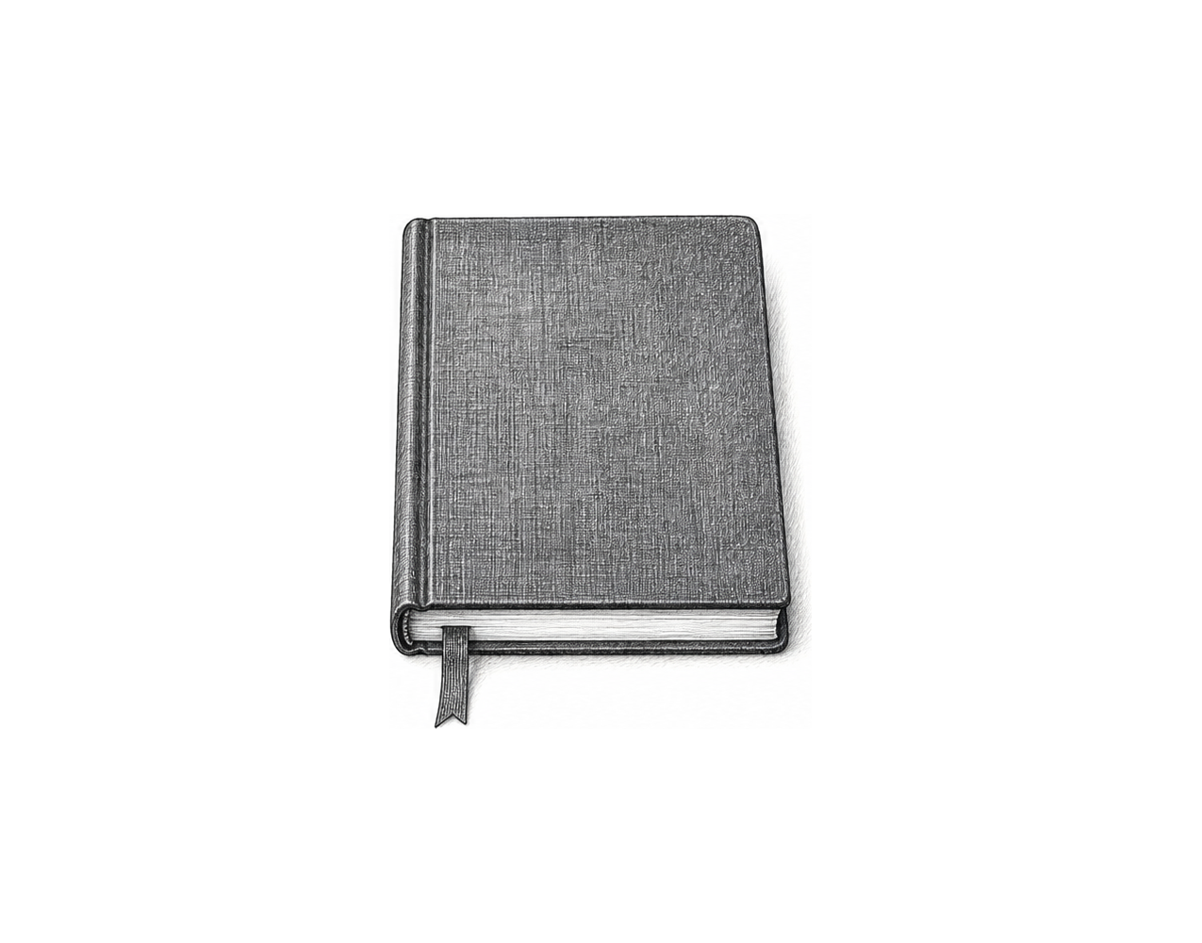

Challenge 2
Extend the example so that, after the replacement, it asks for another position in check_position . Display the item there after "Selected item:", then the updated list. For example, 1, "folder" and 1 display "Selected item: folder".

Challenge 3
Create a scoreboard list called scores holding 0, 0 and 0 for three teams. Twice, ask which team scored (0 to 2) and how many points, then add the points to that team's score. Display the list after "Scores:". For example, 1 and 3, then 1 and 2, display "Scores: [0, 5, 0]".

List Positions and Updates

Fix the code!

This code has errors! Look closely at the code to find the problems:

supplies = ["pencil", "book", "tape"]
print("Old item:", supplies(3))
supplies(1) = "folder"
print(supplies)

Rewrite the whole program in the box below with fixes to the errors.
Click or tap here to enter text.

After you are confident that you fixed all the errors, copy the code from the box and run it.

Did it work correctly on your first try? Did you find all the errors?
Click or tap here to enter text.

